# Unmodified

# Fix 1

## Prints 30

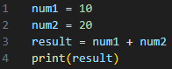

# Fix 2

## Prints “1020”

